

UNIVERSITI TUNKU ABDUL RAHMAN

LEE KONG CHIAN FACULTY OF ENGINEERING AND SCIENCE

UECS2363

SOFTWARE CONSTRUCTION AND CONFIGURATION

Software Engineering

Lecturer: Dr. Farizuwana Akma Binti Zulkifle

Assignment 2: Individual Report

|  |  |  |  |  |
| --- | --- | --- | --- | --- |
|  | **Name** | **Student ID** | **Course** | **Practical Class** |
| 1 | Tan Ying Yao | 1703648 | SE | P3 |

Overview

The project is named “Open Source COVID-19” and is created as an open source website which aggregates many open source projects regrading COVID-19. The project involves at least more than 10,000 people whom had contributed to the project and had 10,000 stars on GitHub. An outbreak of infectious disease known as Coronavirus disease 2019 (COVID-19) was first reported in late December 2019 in Wuhan, Hubei Province, China. Wuhan subsequently underwent a lockdown and suspension of all public transport to contain the disease to no avail. Within a few weeks after the first reported case locally, Malaysia had recorded the largest cumulative number of confirmed COVID-19 infections in Southeast Asia. The disastrous epidemic ravaged all around the globe resulting in at least 500,000 deaths thus far.

The occurrence of a disease outbreak that spreads quickly requires the attention and resources of the government to prevent it from causing a catastrophic panic among the public. COVID-19 is a new type of coronavirus identified by the World Health Organization (WHO). The common symptoms of the disease are dry cough, fever, lack of breath, and even causes pneumonia. Most youngsters end up recovered however a large number of fatal deaths are common in elders. COVID-19 has an incubation period of around 2 weeks and can remain unnoticed for longer. The infected individual can unknowingly spread the disease through close contacts.

Many projects which aims to provide dataset or information regarding the epidemic had sprung out during this period. To remedy this overabundance of information provided, Open Source COVID-19 serves to aggregate the many dashboards or API created by talented programmers all around the globe. The site is maintained daily and contains at least 31 contributors to its development. The dashboard was created with Python, Ruby, CSS, HTML and Shell.



Figure 1: The header of the Open Source COVID-19

Version Control System

GitHub was the main version control system used in the development of this project. Since it is open source, contributors are recommended to give ideas or websites of related subjects to the project. It even has its own contribution guide to allow developers to easily push their changes to the website. As stated in its contribution guide, the primary purpose of the project is to collect useful open source project and display them in categories and region. Github pages (Jekyll) have been used for websites and all data are save in yaml format. Some python scripts are used for postprocessing.

All the data are save in three files in the _data folder which are:

1. Global.yml (contains project used in a global scale)
2. Areas.yml (contains project on certain countries or region)
3. China.yml (contains project and data entries in China)

The repository is open and encourages contributors to open an issue as a feedback with prescribed title and content. To contribute to the project, one can open an issue or a pull request to push their changes to repository. All detailed changes are documented in the change log. The contributors are recommended to open an issue in order to await approval and submission.

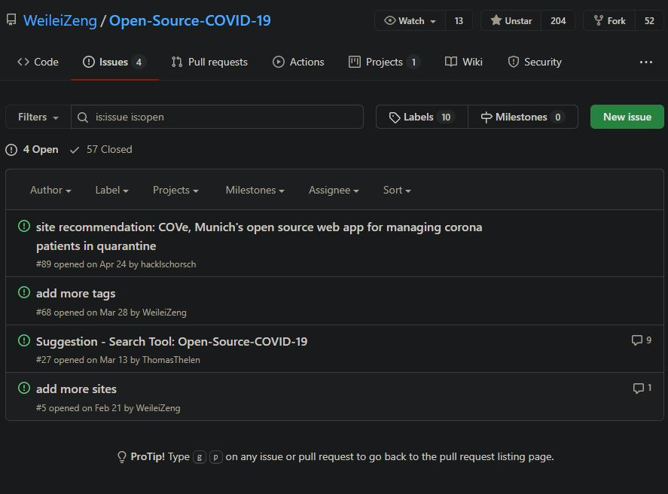

Figure 2: Pull Requests of Open-Source-COVID-19 Repository

Development Tools

The main programming language used in the project are Python, Ruby, CSS, HTML and Shell. Python is an interpreted, object-oriented and high-level programming with dynamic semantics. The high-level data structures and dynamic binding allows it to be used in rapid application development. The website is a rather simple dashboard which is used to display links from other websites.

Ruby is used typically for web application development. In this case however, Jekyll is a Ruby Gem that can be installed in most system was used in the website development. It has many features such as quickly creating basic layouts, templates, blog posts, pages and intensive customizations. The basic installation of the feature is as below:

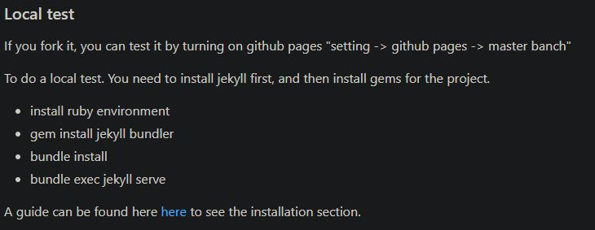

Figure 3: Installation guide for Ruby Gem (Jekyll)

Source: <https://github.com/WeileiZeng/Open-Source-COVID-19/blob/master/contribute.md>

HTML and CSS are also used in the project. CSS describes how HTML elements are displayed on screen and it is both efficient and effective. It is used to control the layout of web pages and stored in CSS files. HTML are standards for creating web pages and structuring web pages. It typically consists a series of elements that are used to describe the content.

Contribution

The project aims to aggregate plenty of projects that are involved with the epidemic. The website features categories such as dashboard, API, Supplies, Research and Development, etc. However, one of the most prolific dataset packages was overlooked and not included in the website which is the Rami Krispin dataset which provides a tidy format dataset of the 2019 Novel Coronavirus COVID-19 (2019-nCoV) epidemic with raw data pulled from JHU. As is the process, I’ve opened the issue on August 8th 2020 and emailed the main contributor about the oversight.

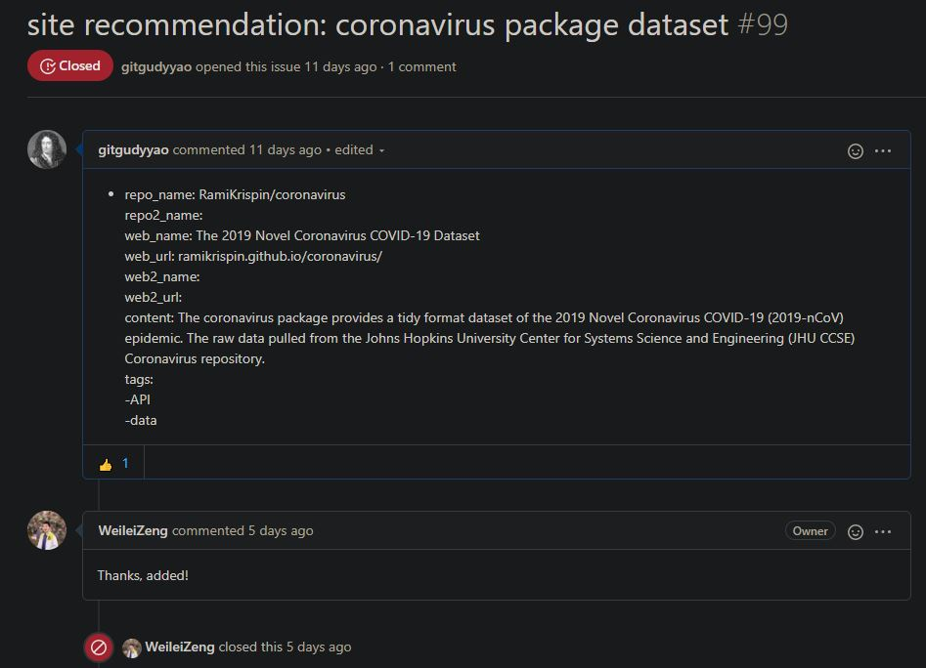 Figure 4: Opening an Issue at repository

As a result, The 2019 Novel Coronavirus COVID-19 Dataset by Rami Krispin was added into the project and allow more people whom are searching for it to find it quickly and efficiently. The link was added to the website and now links to the repository.

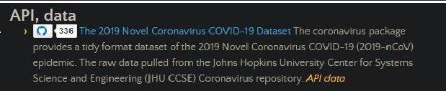

Source: <http://open-source-covid-19.weileizeng.com/>

Analysis & Opinion

The project is a rather simple python dashboard that have a simple objective of displaying links of other repository. The python script is used to get data of repos such as their star counts and calculate the number of websites in different categories. The idea may seem simple but the source code suggest a huge amount of effort put in to automate the retrieving of plenty links of repository.

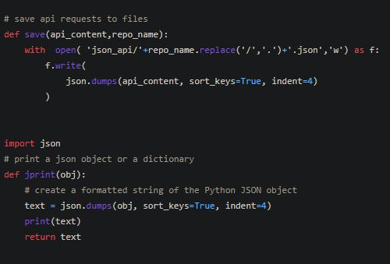

Figure 5: Sample code of the repo

The usage of GitHub as the version control system is brilliant as the website requires plenty of sources in order to function as a content aggregating website. The navigation site is expanded by the number of contributors involved and it is very successful as it receive over 10,000 stars on GitHub. The main contributor was always active in maintaining the repository and results in a very useful repository.

The development tools such as the programming language are effective in conveying the aim of the project. Python was used for the dashboard and Ruby is used to customize the webpage. HTML and CSS are typically used for customizing webpages with proper structure and colors. The quality of code and test scripts are very good as it uses Github API to fetch links of GitHub repository.

The navigation site is extremely useful in collecting multiple open source projects which can help reduce the impact of the epidemic. I’m grateful to be able to contribute meaningfully to the project and help expand it further.